**Q01. Write any five features of HTML5.**

Ans: Five features of HTML5 are given below:

Canvas , Cross-document messaging, Drag and drop, Embedding of Scalable Vector graphics(SVG) directly in HTML, Geolocation, History (browser) management, Microdata, Native media scripting, Offline Web Applications, Web Storage, Web Works.

**Q02. Write the differences between HTML4 and HTML5.**

Ans: 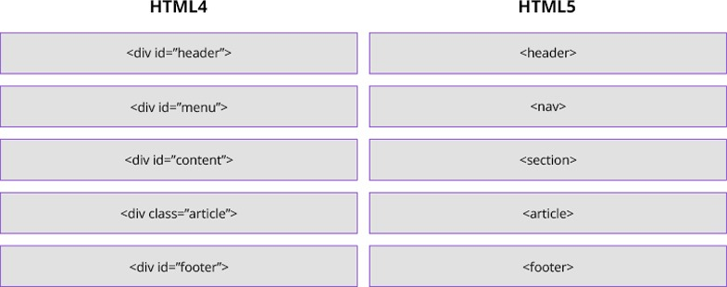

**Q03. What are Inline element and Block-level element?**

Ans: Every HTML element has a default display value depending on what type of element it is. The default display value for most elements is block or inline.  
**Block-level Elements:**A block-level element always starts on a new line and takes up the full width available (stretches out to the left and right as far as it can). Example: The <div> element is a block-level element.  
**Inline Elements:**An inline element does not start on a new line and only takes up as much width as necessary.  
This is an inline <span> element inside a paragraph.

**Q04. What are the basic data types of HTML5?**

Ans: Case information, SGML basic types, Text strings, URIs, Colors, Notes on using colors, Lengths, Content types (MIME types), Language codes, Character encodings, Single characters, Dates and times, Link types, Media descriptors, Script data, Style sheet data, Frame target names.

**Q05. What is the function of manifest attribute of HTML element?**

Ans: Offline applications consist of a manifest listing one or more resources that browser will cache for offline use. Manifest files have the MIME type text/cache-manifest.

**Q06. Meta element is useful for what purposes?**

**Ans:** The <meta> tag is used to provide additional information. This tag is an empty element and so does not have a closing tag but it carries information within its attributes. Google uses metadata, amongst many other signals, to classify pages, or display information about a page in SERPs.

**Q07. How many ways you can define list in HTML page?**

Ans: There are three list types in HTML:

**unordered list** — used to group a set of related items in no particular order

**ordered list** — used to group a set of related items in a specific order

**description list** — used to display name/value pairs such as terms and definitions

Each list type has a specific purpose and meaning in a web page.

**Q08. What are the differences between link and anchor element?**

Ans: Links are HTML elements that are created with the tag <link>. Anchors are HTML elements that are created with the tag <a>. Links are placed inside the <head> section of the document and they are not rendered. They usually describe a relationship between the current document and another document. Anchors are used inside the <body> of the document and they are used to create the well-known Hyperlinks, which allow the user to access resources, either within the same Web page or on other pages.

**Q09. How does del and ins elements are related with each other?**

**Ans**: A text with a deleted part, and a new, inserted part: <p>My favorite color is <del>blue</del> <ins>red</ins>!</p>. The <del> tag defines text that has been deleted from a document. We use <del> and <ins> to markup updates and modifications in a document

**Q10. What are the purposes usemap attribute of img tag?**

Ans: he usemap attribute specifies an image (or an object) as an image-map (an image-map is an image with clickable areas). The usemap attribute is associated with a <map> element's name or id attribute, and creates a relationship between the <img> and the <map>.

**Q11. What is the benefit of using map tag?**

Ans: The <map> tag is used to define a client-side image-map. An image-map is an image with clickable areas. The required name attribute of the <map> element is associated with the <img>'s usemap attribute and creates a relationship between the image and the map. The <map> element contains a number of <area> elements, that defines the clickable areas in the image map.

**Q12. What is the function of autocomplete and placeholder attribute of input tag?**

Ans: The autocomplete attribute specifies whether a form or input field should have autocomplete on or off. When autocomplete is on, the browser automatically completes the input values based on values that the user has entered before. It is possible to have autocomplete "on" for the form, and "off" for specific input fields, or vice versa. The autocomplete attribute works with <form> and the following <input> types: text, search, url, tel, email, password, datepickers, range, and color.

The placeholder attribute specifies a hint that describes the expected value of an input field (a sample value or a short description of the format).The hint is displayed in the input field before the user enters a value.The placeholder attribute works with the following input types: text, search, url, tel, email, and password.

**Q13. When colgroup tag is used in html document and for what purpose?**

**Ans:** The <colgroup> tag specifies a group of one or more columns in a table for formatting. The <colgroup> tag is useful for applying styles to entire columns, instead of repeating the styles for each cell, for each row. The <colgroup> tag must be a child of a <table> element, after any <caption> elements and before any <thead>, <tbody>, <tfoot>, and <tr> elements. To define different properties to a column within a <colgroup>, use the <col> tag within the <colgroup> tag.

**Q14. What do you understand by HTML5 document outline?**

**Ans:**

**<section>**

**<article>**

**<aside>**

**<nav>**

Any of these four elements starts a new section of the outline within the parent element. The idea is to create a more understandable and logical structure, with better semantics.

**Note:** The main, header, and footer elements are not sectioning elements.

**Q15. Mention some use of mark tag?**

Ans: The <mark> tag was introduced in HTML 5. The HTML <mark> tag is used for indicating text as marked or highlighted for reference purposes, due to its relevance in another context.

**Q16. What the differences are between embed and object element?**

**Ans:** The <embed> tag defines a container for an external application or interactive content (a plug-in).

The <object> tag defines an embedded object within an HTML document. Use this element to embed multimedia (like audio, video, Java applets, ActiveX, PDF, and Flash) in your web pages. We can also use the <object> tag to embed another webpage into your HTML document. We can use the <param> tag to pass parameters to plugins that have been embedded with the <object> tag.

**Q17. Briefly describe the preload attribute values of video element.**

Ans: The preload attribute specifies if and how the author thinks that the video should be loaded when the page loads. The preload attribute allows the author to provide a hint to the browser about what he/she thinks will lead to the best user experience. This attribute may be ignored in some instances.

**Note**: The preload attribute is ignored if autoplay is present.

**Q18.Why canvas tag is used?**

Ans: The HTML <canvas> element is used to draw graphics, on the fly, via scripting (usually JavaScript).The <canvas> element is only a container for graphics. You must use a script to actually draw the graphics.Canvas has several methods for drawing paths, boxes, circles, text, and adding images.

**Q19. Why doctype is used?**

Answer: A DOCTYPE tells the browser what mode in which to render, which improves interoperability, and it makes easier when developing and debugging code.

**Q20. What do you mean by Character Entities?**

**Ans:** A character entity represents a character in a document’s character set. Some common character entities are &amp; for an ampersand, &nbsp : for a nonbreaking space, &lt; for a less than sign, &gt; for a greater than sign etc.

**Q21. Explain two types of progress element.**

Ans: The <progress> element represents the completion progress of a task. This element normally used to indicate how much of a task has been completed, such as loading something on a page or registration process. It is typically displayed as a progress bar and often marked as a percentage from 0 to 100%.

The following table summarizes the usages context and the version history of this tag.

**Placement**: Inline

**Content**: Inline and text, but no <progress> among its descendants

**Start/End Tag:** Start tag: required, End tag: required

Q22. In IE6, what problem arises when multiple buttons are used? How can you solve this problem?

**Ans:**